**Project Documentation**

**Introduction:**

The "ChatGPT API Integration" project aims to seamlessly integrate the capabilities of OpenAI's ChatGPT API into a Laravel-based application. ChatGPT, powered by cutting-edge natural language processing (NLP) models, enables conversational interactions that are contextually relevant and engaging. This integration allows users to leverage the power of ChatGPT within the Laravel ecosystem, opening up possibilities for enhancing user experiences, automating tasks, and facilitating natural language understanding.

**Project name:** Creative Quill

Creative quill with ChatGPT API integration and sanctum authentication system.

**Installation**:

From Laravel documentation to create fresh Laravel project. The project name is Creative-Quill and also install project related file.

Installing sanctum library for login and registration authentication. Install the API integration related file from command prompt.

Firstly run



Then

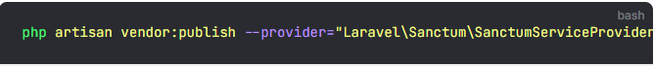

Next, if I plan to utilize Sanctum to authenticate a SPA, I should add Sanctum's middleware to my API middleware group within my application's app/Http/Kernel.php file:

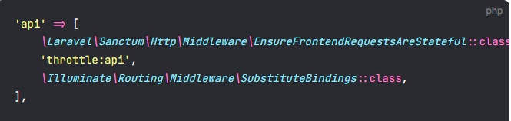

Finlay below this command and migrate auth system.



**Serve the Application**: Start the Laravel development server to serve the application locally

**Project Configuration:**

Before integrating the ChatGPT API into the Laravel project, I ensure that the project is properly configured to accommodate the API integration. Follow these steps to configure the project settings:

**Environment variables**:

Open the **.env** file located at the root of my Laravel project.

Define environment variables required for the ChatGPT API integration, such as API keys, endpoints, and any other configuration parameters.

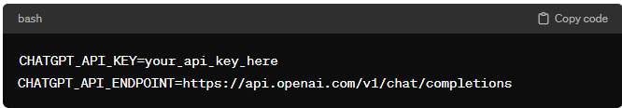

ChatGPT API configuration:

After configuring the Laravel project, focus on setting up the ChatGPT API integration. Follow these steps to configure the interaction with the ChatGPT API:

**API key authentication:**

Obtain an API key from OpenAI to authenticate requests to the ChatGPT API. Store the API key securely as an environment variable or in a configuration file



**API endpoint:**

Define the API endpoint for ChatGPT requests. The endpoint may vary based on the specific API version and functionality required.



**Usages:**

**Initialize ChatGPT client**: Initialize an instance of the ChatGPT client class with my API key and endpoint

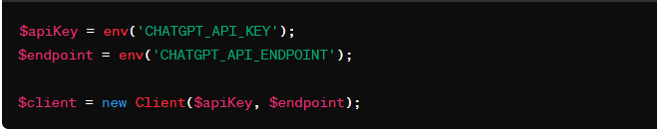

**Sending request to chatGPT API:**

Use the initialized client to send requests to the ChatGPT API. Depending on my use case, you may need to provide additional parameters such as prompt text and completion settings

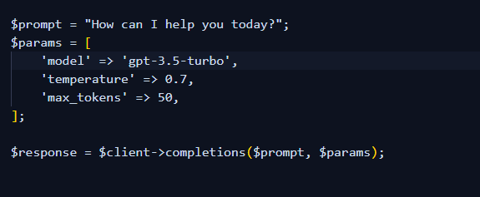

**Handling API response:**

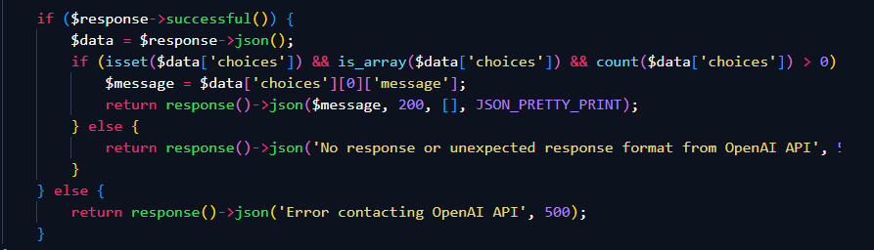

**Authentication:**

This project login and register user authentication with sanctum. This system properly authenticated but don’t implement front-end design part.

And ChatGPT API integration are use to middleware and user also separated from login and register system. User cannot enter the GPT area without login.

**Secure storage:** Ensure that API keys are stored securely, such as using Laravel's encrypted environment variables or dedicated secret management solutions

**Authorize policies:** Implement authorization policies within my Laravel application to restrict access to sensitive operations or endpoints that interact with the ChatGPT API.

**Rate limited:** Monitor and enforce rate limits for API requests to prevent abuse or excessive usage, both on the client side and within the Laravel application.

**Route:**

Routes in Laravel define the entry points for incoming HTTP requests and map them to corresponding controller actions or closures. When integrating the ChatGPT API into myLaravel project, i define custom routes to handle interactions with the API and other related functionalities.

**Route file location**:

Open the **routes/web.php and api.php** file in your Laravel project. This file contains route definitions for web-based HTTP requests.

This route is front-end part to route their page location and request access.

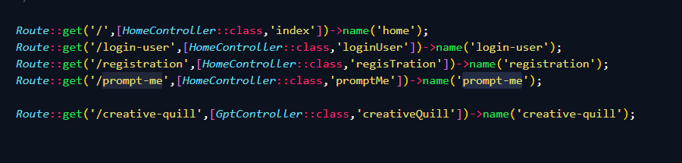

This is api.php which routing system to sanctum authentication login and registration system.

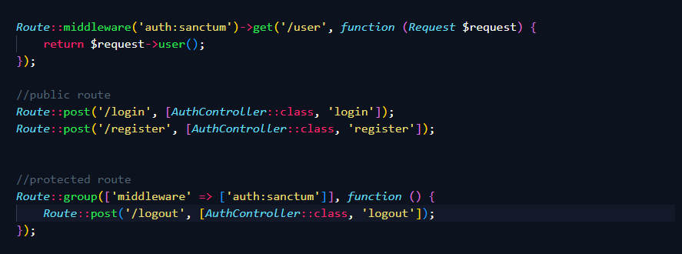

**Resource full naming:** Use descriptive route names that reflect the purpose and functionality of each route.

**Group routing**: Group related routes using route prefixes or middleware to improve organization and clarity.

**Controller:**

Controllers in Laravel serve as intermediaries between routes and application logic, handling incoming HTTP requests and generating appropriate responses. When integrating the ChatGPT API into myLaravel project, I will likely create custom controllers to encapsulate the logic for interacting with the API and processing its responses

**Controller creation:**

Create controller classes within the **app/Http/Controller’s** directory of my Laravel project.

**Controller structure**:

Define public methods within the controller class to handle different types of requests or actions related to ChatGPT API integration.

Each method typically corresponds to a specific route or endpoint defined in my application.

Name of the controller I create to integration project:

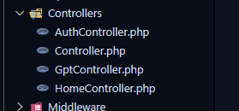

**Testing controller:**

All controller ok but GptController can’t run unexpected error. I don’t know why the program cannot run but all codes are ok.

**Model:**

In Laravel, models represent the data structures and interactions with the underlying database tables. When integrating the ChatGPT API into my Laravel project, I need to define custom models to manage data related to ChatGPT interactions, such as chat sessions, messages, or user preferences

**Model file location**:

Create model files within the **app** directory of my Laravel project, typically under the **app\Models** namespace

**Database migration:**

This project user model create and this model could be migration and authentication system.

**Summery**

In conclusion, the "ChatGPT API Integration" documentation provides comprehensive guidance on integrating the ChatGPT API into my Laravel project. Throughout this documentation, I have to learned how to set up the project, configure API integration, define routes, manage data models, and more. By following the instructions and best practices outlined in this documentation, I can effectively leverage the power of ChatGPT within my Laravel application to enhance user experiences, automate tasks, and facilitate natural language understanding.

Key takeaway:

Here are some key takeaways from this documentation:

Installation and configuration: Properly configure my Laravel project and set up the environment variables required for integrating the ChatGPT API

User guideline Utilize ChatGPT API functionalities within my Laravel application to generate text responses, engage in conversations, and perform natural language processing tasks.

Security and authentication: Implement secure authentication mechanisms to protect API keys and authenticate requests to the ChatGPT API .

Routing define and model management: Define custom routes and models to handle interactions with the ChatGPT API and manage data related to chat sessions, messages, and users.

But I don’t properly use Back-End data to front-end implementation. Because time is short and this month is Ramadan month. I am a big Lerner, I hope this project taught me more and I want to take more challenge just I need a platform, I want an opportunity.